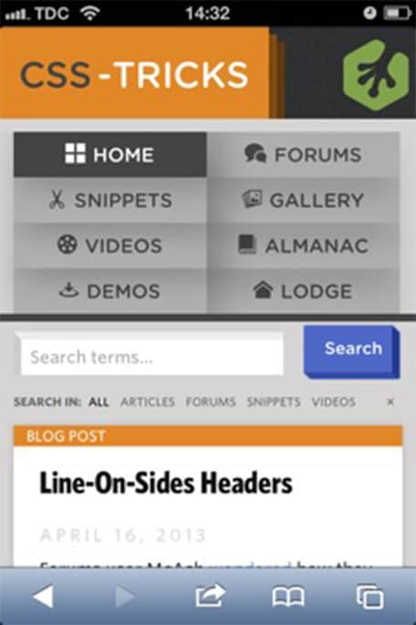

BAD IMAGE
This design lacks several basic features.
No Sticky Navigation:
- Navigation disappears when you scroll, making it harder to access key actions quickly.
No User Account/Profile Access:
- There’s no visible way to log in or access a user profile/dashboard.
Lack of Touch-Friendly Spacing:
- Buttons and links are too close together, increasing the risk of mis-taps.
No Visual Feedback on Tap:
- The UI does not show any tap feedback (highlight or animation), which is essential for mobile interactivity.
No Personalization or Smart Features:
- Lacks suggested content, trending articles, or a recently viewed section.

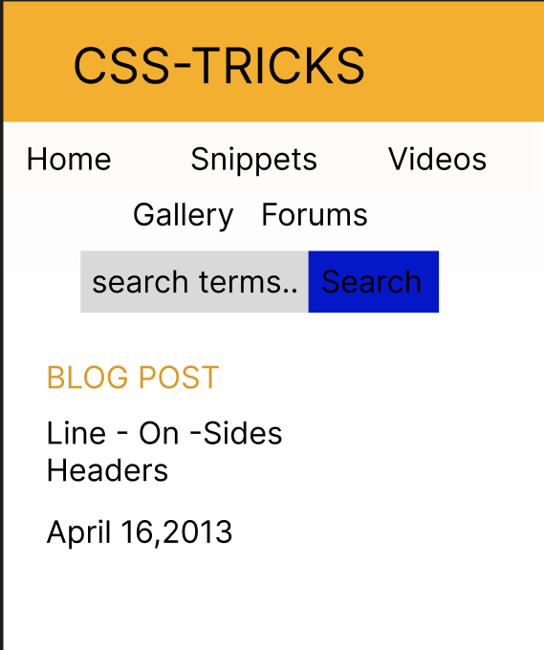

Good image
This design consists of all the vital features that the previous one lacks.
Simplified Navigation:
- The main navigation items (Home, Snippets, Videos, Gallery, Forums) are clearly listed with ample spacing.
- Avoids clutter by reducing the number of visible categories.
- Straightforward layout improves scan-ability.
Clean and Minimal Look:
- Uses whitespace effectively to separate sections.
- No unnecessary graphical elements or visual noise.
Improved Readability:
- Font sizes are consistent and legible.
- Clear visual hierarchy (e.g., "BLOG POST" in gold stands out).
Better Search Bar Design:
- Search input and button are clearly defined.
- Good contrast between the search field (gray) and the button (blue).
Mobile-Friendly Layout:
- Everything is vertically stacked, which is ideal for touch-based interaction.
- Tap targets are large enough for fingers.
Modern Aesthetic:
- Use of flat design (no gradients or outdated shadows).
- Looks contemporary and uncluttered.

